**Team Name: GlassMates**

Anitta Varghese​

Divya Kurava​

MD Kamruzzaman Kamrul​

Manoj Potnuru​

**unraveling legal insights using graph database & openai**

**A Comprehensive Exploration of Legal Support Systems using chatbot**

Course No. – CIS8695

Course Title – Big Data Analytics Experience

Submitted to -​

​

Dr. Vijaykumar Gandapodi​

Executive in Residence, Georgia State University​

TABLE OF CONTENTS

I. INTRODUCTION 1

A. Background of the Project 1

B. Motivation for Developing BetterCallSaul 1

C. Objectives of the Project 1

D. Overview of the Report Structure 2

II. BUSINESS PROBLEM 3

A. Identification of Legal Information Retrieval Challenges 3

B. Importance of Efficient Legal Data Analysis 3

C. Role of BetterCallSaul in Addressing Business Needs 3

D. Vision 4

III. SOLUTION 5

A. Design Overview 5

B. Target Audience 5

C. Solution Objectives 6

D. Challenges Faced 6

E. Empowering Access 6

IV. DATA SOURCE 7

A. Introduction to the Caselaw Access Project 7

B. Introduction to the Caselaw Access Project 7

C. Scope of the Dataset 8

D. Versatility and Adaptability 8

E. Unique Opportunity for Legal Insights 8

F. Accessibility and Inclusivity 8

V. DATA QUALITY 9

A. Importance of Data Quality in Legal Analytics 9

B. Data Cleaning and Preprocessing Techniques 9

C. Ensuring Data Integrity for BetterCallSaul 10

VI. DATA PROCESSING 11

A. Sample Data Exploration 11

B. Whole Data Exploration 13

VII. ETL (EXTRACT, TRANSFORM, LOAD) 17

Overview of ETL Process in BetterCallSaul 17

A. Techniques Used for Extracting Legal Case Data 17

B. Transformation and Loading Processes 18

C. Loading Data into Neo4j Graph Database 18

VIII. ARCHITECTURE 19

A. Design and Architecture of BetterCallSaul 19

B. Components and Modules of the Chatbot System 19

C. Scalability and Performance Considerations 20

D. Code Summary 20

IX. STORAGE (Neo4J) 22

A. Storage Requirements for Legal Case Data 22

B. Data Storage Solutions Employed in BetterCallSaul 22

C. Ensuring Data Security and Compliance 24

D. Popular Use Cases for Neo4j 25

X. ANSWER RETRIEVAL 26

A. Vectorize the Question 26

B. Retrieve Closest Chunk Based on Vector Similarity 26

C. Question + Docs (Relevancy) 26

D. Answer the Question 27

XI. CYPHER AND RAG INTEGRATION: ENHANCING ANSWER RETRIEVAL 28

A. Cypher: The Query Language for Graph Databases 28

B. RAG: The Retrieval-Aggregation-Generation Model 28

C. Integration of Cypher and RAG: Synergy for Accurate Response Generation 29

XII. ANALYTICS 31

A. Natural Language Processing Techniques Used 31

B. Machine Learning Algorithms for Legal Data Analysis 32

C. Analytical Capabilities of BetterCallSaul 33

XIII. DEMO 34

XIV. SOLUTION OVERVIEW 36

A. Chatbot Interface 36

B. NLP Engine 36

C. Caselaw Database 36

D. Text Embeddings and Graph Database 36

E. Cloud Integration 36

F. Data Privacy and Compliance 37

XV. FINANCIAL IMPACT, POTENTIAL USES, AND FUTURE APPLICATIONS 38

A. Financial Impact 38

B. Potential Uses and Additional Features 38

C. Application in Other Domains 39

XVI. CONCLUSION 40

XVII. PERSONAL CONCLUSION – MANOJ 41

A. Introduction 41

B. Personal Motivation and Interest 41

C. Data Sourcing Struggles 41

D. My Technical Learnings 41

1. Navigating RAG Architecture: 41

2. Exploring Graph Databases for Complex Data Relationships: 42

3. Cypher Queries: 42

4. Synergy of RAG and Graph Databases: 42

5. Streamlit integration for user-friendly UI: 42

6. Conclusive Learnings from AI Technologies: 42

E. Challenges, Growth, and the Synergy Between AI and Legal Frameworks: 43

F. Future Scope and Development 43

G. Conclusion 43

XVIII. REFERENCES 44

**TABLE OF FIGURES**

Figure 1 - Illinois Case Law Data Source 7

Figure 2 - Diagram of distribution for Not Assigned Values 14

Figure 3 - Distribution of Not assigned values for parties. 15

Figure 4 - Architecture of BetterCallSaul 19

Figure 5- Neo4J integration with different services. 22

Figure 6 - An example of how a graph database looks like 23

Figure 7 - An example of Neo4J node structure and relationship. 24

Figure 8- Neo4j use cases. 25

Figure 9 - Using cypher queries with Neo4j Database for prediction 28

Figure 10 - RAG Architecture for answering queries 29

Figure 11 - Visualizing Steps in RAG 30

Figure 12 - Augmented Chatbot Solution Architecture 37

# **I. INTRODUCTION**

In today's dynamic legal landscape, characterized by an ever-expanding volume of legal information, the traditional methods of legal research and analysis are being increasingly challenged. The sheer magnitude and complexity of legal data makes it arduous for legal professionals to efficiently extract, interpret, and apply relevant information to their cases or research endeavors. As such, there arises a pressing need for innovative solutions that can streamline the process of legal information retrieval and analysis, facilitating quicker and more informed decision-making.

## A. Background of the Project

The genesis of BetterCallSaul can be traced back to the growing recognition within the legal community of the limitations inherent in traditional research methodologies. Despite the advent of digital databases and online resources, legal professionals continue to grapple with the time-consuming and often overwhelming task of sifting through vast troves of legal documents and precedents. The inefficiencies associated with manual research not only impede productivity but also pose risks of oversight or omission, potentially undermining the quality and accuracy of legal analyses.

In response to these challenges, the BetterCallSaul project emerged as a concerted effort to harness the power of artificial intelligence (AI) and natural language processing (NLP) to revolutionize legal research and analysis. By leveraging cutting-edge technologies, BetterCallSaul aims to empower legal practitioners with a sophisticated tool that can swiftly and intelligently navigate through complex legal datasets, extracting pertinent insights and delivering actionable information in a fraction of the time required by conventional methods.

## B. Motivation for Developing BetterCallSaul

The motivation behind the development of BetterCallSaul is rooted in the imperative to bridge the gap between the burgeoning volume of legal information and the limited capacity of legal professionals to effectively manage and leverage this wealth of data. As the pace of legal proceedings accelerates and the demands for precision and timeliness escalate, there arises a critical need for tools that can augment human capabilities, enabling practitioners to stay abreast of the latest legal developments and make well-informed decisions with confidence.

Moreover, the advent of AI-driven technologies has ushered in a new era of possibility for the legal industry, offering unprecedented opportunities to enhance efficiency, accuracy, and accessibility in legal research and analysis. BetterCallSaul represents a pioneering endeavor to harness these technological advancements and channel them towards the advancement of legal scholarship, practice, and advocacy, thereby fostering a more equitable and efficient administration of justice.

## C. Objectives of the Project

The BetterCallSaul project sets out to achieve a multifaceted array of objectives, each aimed at advancing the state-of-the-art in legal analytics and empowering users with transformative capabilities:

1. Develop a robust and versatile legal chatbot endowed with the ability to comprehend and respond to queries pertaining to a diverse range of legal topics and jurisdictions.
2. Employ state-of-the-art NLP algorithms and machine learning techniques to train the chatbot on a comprehensive dataset of legal cases, statutes, and regulations, ensuring the accuracy and relevance of its responses.
3. Design an intuitive and user-friendly interface that facilitates seamless interaction with the chatbot, catering to the diverse needs and preferences of legal practitioners, researchers, and other stakeholders.
4. Explore the potential applications of BetterCallSaul across various domains of the legal profession, including but not limited to litigation support, contract analysis, legal research, and regulatory compliance.
5. Evaluate the efficacy and performance of BetterCallSaul through rigorous testing, validation, and user feedback, iteratively refining and enhancing its capabilities based on real-world usage and insights.

## D. Overview of the Report Structure

This report aims to provide a comprehensive exploration of the BetterCallSaul project, covering its conceptual foundation, technical implementation, and practical implications. Subsequent sections will delve into specific aspects, including the business problem addressed, technical solution offered, methodologies employed, outcomes of implementation, challenges encountered, lessons learned, and prospects for future enhancements. Through this structured approach, readers will gain a holistic understanding of BetterCallSaul's significance in shaping the future of legal analytics and decision support systems.

# **II. BUSINESS PROBLEM**

## A. Identification of Legal Information Retrieval Challenges

In the realm of legal practice and scholarship, the acquisition and analysis of relevant legal information constitute a foundational aspect of decision-making and strategic planning. However, traditional methods of legal research and information retrieval are often hindered by inefficiencies and limitations that impede the timely and accurate extraction of pertinent insights. Key challenges include:

1. **Information Overload**: The exponential growth of legal databases and repositories has resulted in information overload, making it increasingly difficult for legal professionals to sift through vast volumes of data to identify relevant precedents, statutes, and case law.
2. **Complexity of Legal Language**: Legal documents are characterized by complex language structures, nuanced terminology, and subtle distinctions, posing challenges for automated processing and comprehension.
3. **Fragmented Data Sources**: Legal information is often dispersed across multiple sources and jurisdictions, further complicating the task of comprehensive and coherent analysis.
4. **Time and Resource Constraints**: Legal practitioners operate within tight deadlines and resource constraints, necessitating streamlined and efficient methods of information retrieval and analysis.

## B. Importance of Efficient Legal Data Analysis

The ability to access, analyze, and interpret legal data with speed and precision is paramount for legal practitioners, researchers, and policymakers alike. Efficient legal data analysis enables:

1. **Informed Decision-Making**: By providing timely access to relevant legal precedents, statutes, and case law, efficient data analysis empowers legal professionals to make well-informed decisions with confidence and clarity.
2. **Enhanced Productivity**: Streamlining the process of legal research and analysis reduces the time and effort required to extract insights, thereby boosting productivity and efficiency.
3. **Risk Mitigation**: Accurate and comprehensive legal data analysis helps mitigate the risk of errors, oversights, or misinterpretations, minimizing the potential for adverse outcomes in legal proceedings or transactions.
4. **Knowledge Discovery**: Systematic analysis of legal data can uncover patterns, trends, and correlations that may not be readily apparent through manual examination, facilitating knowledge discovery and innovation in legal scholarship and practice.

## C. Role of BetterCallSaul in Addressing Business Needs

BetterCallSaul is poised to address the challenges and fulfill the evolving needs of legal practitioners and researchers by:

1. **Automating Legal Information Retrieval**: Through its AI-powered chatbot interface, BetterCallSaul automates the process of legal information retrieval, enabling users to pose queries in natural language and receive relevant responses in real-time.
2. **Enhancing Accuracy and Relevance**: Leveraging advanced NLP algorithms and machine learning techniques, BetterCallSaul ensures the accuracy and relevance of its responses by continuously learning from user interactions and feedback.
3. **Streamlining Decision-Making Processes**: By providing rapid access to comprehensive legal insights, BetterCallSaul streamlines decision-making processes, enabling users to quickly assess the merits of legal arguments, assess risks, and identify relevant precedents.
4. **Empowering Legal Professionals**: BetterCallSaul empowers legal professionals with a powerful tool that augments their expertise, enabling them to focus their time and attention on higher-level strategic tasks while delegating routine research and analysis tasks to the chatbot.

In the subsequent sections of this report, we will delve deeper into the technical architecture, implementation strategies, and practical implications of BetterCallSaul, elucidating its potential to transform the landscape of legal analytics and decision support systems. Through a systematic exploration of its capabilities and functionalities, we aim to demonstrate the value proposition of BetterCallSaul in addressing the pressing business needs of the legal profession.

## D. Vision

The vision driving the development and deployment of BetterCallSaul is rooted in the aspiration to bridge the gap between legal expertise and accessibility, thereby empowering individuals to make informed decisions and advocate for their rights effectively. By democratizing access to legal information through an intuitive chatbot interface, BetterCallSaul seeks to achieve the following objectives:

1. **Bridge Legal Expertise-Accessibility Gap**: In many jurisdictions, access to legal expertise is often limited by financial constraints or geographical barriers, leaving individuals without the means to seek professional legal advice or representation. BetterCallSaul endeavors to bridge this gap by providing an accessible and user-friendly platform for accessing legal information and insights, regardless of one's socioeconomic status or geographic location.
2. **Aids Immediate Legal Needs**: For individuals facing legal challenges or inquiries, timely access to accurate legal information is essential for navigating complex legal processes and making informed decisions. BetterCallSaul serves as a valuable resource for addressing immediate legal needs, offering real-time assistance and guidance in understanding rights, obligations, and available legal remedies.
3. **Promotes Legal Literacy**: Beyond addressing immediate legal concerns, BetterCallSaul plays a pivotal role in promoting legal literacy and empowerment within the community. By demystifying legal concepts and procedures through interactive dialogue and educational resources, BetterCallSaul empowers users to develop a deeper understanding of their legal rights and responsibilities, fostering a culture of informed citizenship and civic engagement.
4. **Contribute to a More Equitable Society**: By leveling the playing field and democratizing access to legal information, BetterCallSaul contributes to the creation of a more equitable and just society. By empowering individuals with the knowledge and resources needed to assert their legal rights and advocate for justice, BetterCallSaul facilitates greater inclusivity and fairness in the legal system, thereby advancing the cause of social justice and equality.

In summary, the vision for BetterCallSaul transcends mere technological innovation; it embodies a commitment to leveraging technology as a force for positive social change. By harnessing the power of AI and natural language processing to democratize access to legal information and empower individuals to make informed decisions, BetterCallSaul aspires to create a more equitable and just society where legal rights and remedies are accessible to all.

Top of Form

# **III. SOLUTION**

## A. Design Overview

The design of BetterCallSaul embodies a fusion of cutting-edge technology and user-centric principles, aiming to revolutionize the way legal information is accessed and utilized. At its core, BetterCallSaul leverages state-of-the-art Language Model-based Legal (LLM) technology, specifically trained on legal texts and documents, to power a specialized chatbot capable of assisting users with a diverse range of legal queries. Key components of the solution include:

1. **Language Model-based Legal Technology**: BetterCallSaul harnesses the advanced capabilities of Language Model-based Legal (LLM) technology, enabling it to understand and generate legal language with unparalleled accuracy and contextuality. This technology forms the foundation of BetterCallSaul's ability to comprehend user queries and provide relevant legal information and insights.
2. **Chatbot Interface**: BetterCallSaul features a user-friendly chatbot interface that allows users to interact with the system using natural language queries. This intuitive interface facilitates seamless communication and enhances user experience, catering to individuals from diverse backgrounds, including those with limited technical expertise.
3. **Embedding-based Search**: The core functionality of BetterCallSaul is powered by embedding-based search techniques, which enable the chatbot to analyze and retrieve relevant legal documents and precedents based on semantic similarities and contextual relevance. By employing advanced embedding models, BetterCallSaul ensures that users receive the most pertinent information for their queries, enhancing the accuracy and comprehensiveness of search results.

## B. Target Audience

BetterCallSaul is designed to serve a diverse spectrum of users, spanning from law students and legal researchers to practicing legal professionals and the general public. The solution aims to cater to the following user segments:

1. **Law Students**: BetterCallSaul serves as a valuable educational tool for law students, offering access to relevant case law, statutes, and legal analyses to supplement their legal education and deepen their understanding of legal principles and concepts.
2. **Legal Researchers**: Legal researchers can leverage BetterCallSaul to streamline their research processes, conduct comprehensive literature reviews, and identify relevant precedents for their research projects or scholarly publications.
3. **Legal Professionals**: BetterCallSaul enhances the efficiency and productivity of legal professionals, providing quick access to relevant case law precedents, streamlined research capabilities, and informed advice to support their case preparation, client counseling, and decision-making processes.
4. **General Public**: Individuals seeking legal information for personal or professional reasons can benefit from BetterCallSaul's user-friendly interface and comprehensive database of legal documents. Whether understanding their rights, researching legal issues, or seeking guidance on specific legal matters, BetterCallSaul offers an accessible and reliable resource for navigating the complexities of the legal system.

## C. Solution Objectives

The objectives of BetterCallSaul are multifaceted, encompassing several key dimensions aimed at maximizing its utility and impact:

1. **Democratize Legal Information Access**: BetterCallSaul seeks to democratize access to legal information by providing a user-friendly platform that empowers individuals from diverse backgrounds to access, understand, and apply legal knowledge effectively.
2. **Complement Legal Professionals**: While BetterCallSaul is not intended to replace human legal professionals, it serves as a valuable complement by offering quick and reliable assistance with routine legal queries, thereby freeing up professionals' time for more complex and strategic tasks.
3. **Enhance Legal Literacy**: By providing intuitive access to legal information and insights, BetterCallSaul promotes legal literacy and empowerment within the community, enabling individuals to make informed decisions and advocate for their rights more effectively.
4. **Bridge Legal Expertise-Accessibility Gap**: BetterCallSaul aims to bridge the gap between legal expertise and accessibility, ensuring that legal information and resources are accessible to all, regardless of socioeconomic status or geographic location.

## D. Challenges Faced

The development and implementation of BetterCallSaul have encountered several challenges, including:

1. **Evolving Laws**: Keeping pace with the constantly evolving legal landscape poses challenges in updating and maintaining the accuracy of legal information within BetterCallSaul.
2. **Interpreting Statutes**: Ensuring accurate interpretation of statutes and legal texts requires sophisticated language understanding capabilities.
3. **Identifying Precedents**: Identifying relevant precedents from vast repositories of legal documents requires advanced search and retrieval techniques.
4. **Understanding Legal Jargon**: Simplifying complex legal language and terminology to make it accessible to non-experts presents a significant challenge.
5. **Comprehending Rights**: Ensuring that BetterCallSaul provides clear and accurate explanations of legal rights and obligations requires careful attention to context and nuance.
6. **Accessing Guidance**: Providing reliable and actionable guidance to users navigating legal complexities requires a robust knowledge base and sophisticated decision-making capabilities.

## E. Empowering Access

Through its innovative design, advanced technology, and user-centric approach, BetterCallSaul seeks to enhance the efficiency and accessibility of legal research, promote legal literacy and empowerment within the community, and make legal knowledge accessible and actionable for all. By bridging the gap between legal expertise and accessibility, BetterCallSaul aims to contribute to a more equitable and informed legal ecosystem.

# **IV. DATA SOURCE**

## A. Introduction to the Caselaw Access Project

The[Library Innovation Lab](http://https/lil.law.harvard.edu/) at the Harvard Law School Library recently published the full corpus of available U.S. case law. Two jurisdictions, Arkansas and Illinois, are freely available online. The following link contains the dataset – https://case.law

As we will see, the dataframe is not yet particularly clean. The goal of this first notebook is to define helper functions to make it easier to load the data into a Pandas dataframe, making it easier to proceed with further analysis.

This is the first part of a series of notebooks. In future kernels, we will try to understand the link between the different parties of the cases and analyze the cases content to find pattern and insights.

In the landscape of modern law, the fusion of technology and legal practice has sparked a transformative wave, with artificial intelligence (AI) emerging as a pivotal force reshaping traditional legal paradigms. At the heart of this evolution lies the indispensable role of data, particularly within the expansive repository of legal case data stored within Neo4j, a preeminent graph database management system renowned for its versatility and scalability. This document embarks on a comprehensive exploration of Neo4j as a pivotal data source for AI-driven legal solutions, delving into its extensive scope, inherent versatility, accessibility, and foundational significance in revolutionizing the legal industry.

Figure 1 - Illinois Case Law Data Source

There are two available files, one in text and the other in xml format. For this analysis we will use the *text json* file.

## B. Introduction to the Caselaw Access Project

The Caselaw Access Project, an ambitious initiative spearheaded by the Harvard Law School Library, represents a watershed moment in the quest to democratize access to a comprehensive trove of U.S. caselaw. Positioned at the vanguard of legal data accessibility, this visionary project offers unfettered access to an extensive corpus of published caselaw originating from the state of Illinois, meticulously curated and cataloged in both text and XML formats. With its overarching mission to enhance legal transparency and knowledge dissemination, the Caselaw Access Project stands as a beacon of innovation and inclusivity, serving as a cornerstone data source for our AI-driven chatbot project aimed at broadening access to legal insights.

## C. Scope of the Dataset

The dataset meticulously curated by the Caselaw Access Project encompasses a sweeping spectrum of legal documents, ranging from judicial opinions and judgments to rulings, sourced from Illinois courts spanning multiple decades. This rich repository offers a panoramic view of the legal landscape within the state, capturing the nuances of diverse legal topics and cases that have shaped legal precedents over time. Moreover, the dataset's inclusivity extends beyond textual data, incorporating XML formats that enhance its versatility and analytical capabilities. This comprehensive dataset serves as a veritable treasure trove of legal knowledge, empowering our chatbot project to navigate the intricacies of legal queries with precision and nuance, thereby revolutionizing the accessibility of legal information to individuals from all walks of life.

## D. Versatility and Adaptability

Within the intricate tapestry of legal data, the Caselaw Access Project dataset shines as a beacon of versatility and adaptability, seamlessly aligning with the evolving needs of our AI-driven chatbot project. The dataset's provision in both text and XML formats affords unparalleled flexibility, enabling seamless integration with our chatbot architecture and natural language processing algorithms. This inherent adaptability empowers our project to extract, transform, and analyze data with unparalleled efficiency, ensuring that our chatbot can furnish accurate and contextually relevant responses to an extensive array of legal inquiries. By harnessing the diverse modalities of the dataset, ranging from textual documents to structured XML data, our chatbot emerges as a sophisticated legal assistant, capable of navigating the labyrinth of legal queries with dexterity and precision.

## E. Unique Opportunity for Legal Insights

Embracing the Caselaw Access Project dataset presents an unparalleled opportunity for our project to glean profound insights from decades of legal precedents and case law. This expansive repository serves as a treasure trove of legal knowledge, providing our chatbot with a robust foundation upon which to anchor its decision-making processes and response generation mechanisms. The dataset's depth and breadth afford our chatbot the requisite context and background to address an extensive spectrum of legal inquiries with finesse and accuracy, thereby elevating the quality and reliability of the services rendered. By harnessing the collective wisdom embedded within the dataset, our chatbot transcends the confines of traditional legal research, offering users an immersive and enlightening journey through the annals of legal history.

## F. Accessibility and Inclusivity

Central to the ethos of the Caselaw Access Project is the unwavering commitment to accessibility and inclusivity, ideals that resonate deeply with the core principles of our chatbot project. By virtue of its freely accessible nature, the dataset dismantles barriers to legal information, ensuring equitable access for individuals from diverse socio-economic backgrounds and geographic locations. This democratization of legal knowledge aligns seamlessly with our project's mission to foster legal literacy and empower individuals with the tools needed to navigate the complexities of the legal landscape. Furthermore, the dataset's online availability engenders a culture of openness and collaboration, inviting stakeholders from across the legal spectrum to contribute to its enrichment and evolution. Through its inclusive design and accessible framework, the dataset paves the way for a more equitable and informed society, where legal insights are not merely the purview of a select few, but the birthright of every individual.

# **V. DATA QUALITY**

## A. Importance of Data Quality in Legal Analytics

In the realm of legal analytics, the importance of data quality cannot be overstated. The accuracy, completeness, and reliability of the underlying data directly impact the effectiveness and credibility of legal insights and recommendations generated by analytical tools such as BetterCallSaul. Several key factors underscore the significance of data quality in legal analytics:

1. **Informed Decision-Making**: Legal professionals and individuals relying on legal analytics tools require accurate and reliable data to make informed decisions and navigate complex legal landscapes effectively. Poor data quality can lead to erroneous conclusions, potentially resulting in adverse outcomes in legal proceedings or transactions.
2. **Legal Compliance**: Ensuring compliance with legal standards and regulations necessitates the use of high-quality data that accurately reflects real-world legal scenarios. Inaccurate or outdated data may lead to non-compliance issues, legal liabilities, and reputational damage for individuals and organizations.
3. **Trust and Credibility**: The credibility of legal analytics tools, such as BetterCallSaul, hinges on the integrity and reliability of the underlying data. Users must have confidence in the accuracy and completeness of the data to trust the insights and recommendations provided by the tool.
4. **Effective Legal Research**: Legal researchers rely on high-quality data to conduct thorough and insightful analyses, identify relevant precedents, and uncover emerging legal trends. Poor data quality can impede the research process, leading to incomplete or biased results.
5. **User Experience**: For users of legal analytics tools, such as legal professionals and individuals seeking legal information, a seamless and intuitive user experience depends on the availability of high-quality data. Inconsistent or inaccurate data can disrupt user workflows and diminish the overall utility of the tool.

In light of these considerations, ensuring data quality is paramount for the success and impact of BetterCallSaul in providing accurate, reliable, and actionable legal insights to its users.

## B. Data Cleaning and Preprocessing Techniques

Achieving and maintaining high data quality in our Illinois caselaw dataset requires rigorous data cleaning and preprocessing techniques. Key steps in this process include:

1. **Completeness Assessment**: Meticulously evaluating the presence of essential data elements within each legal case record to ensure comprehensive coverage.
2. **Consistency Verification**: Verifying the synchronization of data across systems and maintaining data integrity through uniform formatting and interpretation.
3. **Conformity Check**: Ensuring adherence to standard definitions and formats by validating data representation against established norms.
4. **Accuracy Validation**: Employing rigorous validation techniques to assess the accuracy of case details, including party names, court decisions, and legal precedents.
5. **Integrity Preservation**: Upholding overall trustworthiness and consistency by prioritizing data integrity and preserving the credibility of legal advice and recommendations.
6. **Timeliness Assessment**: Constantly evaluating the relevance and up-to-dateness of the data to ensure users have access to current and pertinent legal information.

## C. Ensuring Data Integrity for BetterCallSaul

Ensuring data integrity is a foundational aspect of our efforts to deliver a reliable and trustworthy legal analytics tool in the form of BetterCallSaul. To achieve this, we employ a multi-faceted approach that encompasses:

1. **Robust Data Validation**: Implementing robust validation mechanisms to verify the accuracy, completeness, and consistency of our Illinois caselaw dataset. This involves stringent checks for errors, anomalies, and inconsistencies at each stage of the data pipeline.
2. **Data Governance Framework**: Establishing a comprehensive data governance framework to govern the entire lifecycle of our dataset, from acquisition and storage to processing and analysis. This framework includes policies, procedures, and controls to ensure data quality, security, and compliance.
3. **Continuous Monitoring and Improvement**: Instituting processes for continuous monitoring and improvement of data quality, including regular audits, feedback loops, and performance metrics. This iterative approach allows us to identify and address issues promptly, ensuring the ongoing integrity of our dataset.
4. **Transparency and Accountability**: Maintaining transparency and accountability in our data management practices, including clear documentation of data sources, processing methods, and quality assurance procedures. This transparency fosters trust among users and stakeholders in the reliability of BetterCallSaul's legal insights.

# **VI. DATA PROCESSING**

Let's talk about getting our data ready for analysis! Imagine you have a big pile of messy data. Before we can make sense of it, we need to clean it up and organize it properly. That's what data preprocessing is all about.

In this chapter, we'll focus on cleaning up legal data. Legal stuff can be tricky because it's often stored in big, messy files and comes in different shapes and sizes. But don't worry, we'll walk you through the steps using Python tools.

First off, we'll start by sorting through those big files and picking out a smaller, representative sample of the data. This helps us work faster and makes sure we're not overwhelmed by too much information. We'll also deal with complicated data structures like JSON files, using special techniques to handle them.

Next, we'll roll up our sleeves and dive into cleaning the data. We'll fix things like missing information, extra columns we don't need, and any weird quirks in the text. By the time we're done, our data will be neat, tidy, and ready to be analyzed.

Throughout this chapter, we'll take you step-by-step through the process of getting legal data into shape for analysis. Whether you're a researcher, analyst, or just curious about legal data, this chapter will give you the tools you need to make sense of it all. Let's get started!

Let’s dive into Sample Data First.

## Sample Data Exploration

1. **Data Parsing and Sampling:**
   * The initial steps involve loading and parsing large JSON files containing legal data. Given the massive size of the dataset, only a sample of it is extracted for initial analysis, ensuring computational feasibility.
   * A helper function **sample()** is created to efficiently sample the JSON file, providing flexibility to sample by either a fixed size or a percentage of the total data. This function utilizes the **lzma** library to handle compressed files and reads the JSON objects line by line.
   * The sampled data is then normalized using **json_normalize()** to create a flat table structure, making it suitable for analysis in a Pandas DataFrame.
   * Exploratory analysis reveals that certain columns contain JSON-like data, which cannot be expanded directly. Hence, another helper function **expand()** is created to handle the expansion of such columns, thereby enhancing the usability of the dataset.
2. **Data Cleaning:**
   * Lowercasing all text data ensures uniformity and consistency in textual features, facilitating easier manipulation and analysis.
   * Columns with all NaN values are dropped as they do not contribute meaningful information to the analysis. This step helps in reducing the dimensionality of the dataset and optimizing computational resources.
   * Further, columns with constant values are identified and dropped as they do not provide any variability, which is crucial for meaningful analysis. This step streamlines the dataset by removing redundant information.
   * The cleaned dataset is then ready for exploration and understanding, paving the way for deeper analysis and insights into the legal data.
3. **Understanding Data Diversity:**

* The examination of unique values in each column reveals the diversity and complexity of the legal case dataset.
* Approximately 1% of the file data corresponds to around 18k unique cases, providing a substantial starting point for analysis.

***Interpreting the Outputs:***

* The identification of a large number of unique cases underscores the dataset's richness and variability, highlighting the potential for comprehensive analysis.
* This observation emphasizes the need for thorough exploration and understanding of the dataset's characteristics to extract meaningful insights.

1. **Handling Unhashable Data Types:**

* Functions are developed to identify columns containing unhashable data types like dictionaries or lists.
* Columns with unhashable data types are temporarily dropped to simplify the initial exploration process.

***Interpreting the Outputs:***

* The identification of columns with unhashable data types highlights the dataset's complexity and the challenges associated with traditional analysis methods.
* Temporarily dropping these columns allows us to focus on hashable data types for initial exploration, while also indicating the need for specialized handling techniques in future analyses.

1. **Case Details Examination:**

* A single case from the dataset is selected for detailed analysis to explore its attributes and contents.
* The selected case provides insights into different columns, including court details, decision date, attorneys involved, and citation information.

***Interpreting the Outputs:***

* The examination of a specific case offers a micro-level view of the dataset, enabling researchers to understand the variability and complexity of case details.
* By focusing on individual cases, patterns, trends, and anomalies within the dataset can be identified, guiding subsequent analysis and research endeavors.

1. **Case Content Analysis:**

* The selected case's 'head_matter' field is explored, providing textual details about the case, including parties involved and legal proceedings.
* Information such as court ID, decision date, docket number, and citation details are examined to understand the context and background of the case.

***Interpreting the Outputs:***

* The textual description of the case offers insights into the legal proceedings, including the parties involved, court decisions, and relevant dates.
* Details such as attorneys representing each party and the citation format provide additional context for understanding the case within the broader legal framework.

1. **Attorney and Party Representation:**

* The involvement of attorneys representing the appellant and appellee sides is identified, shedding light on legal representation dynamics.
* Information about the state's attorney and defender project directors provides insights into the legal resources available to different parties.

***Interpreting the Outputs:***

* Identifying attorneys and legal representatives involved in the case highlights the legal expertise and resources dedicated to each party's defense and prosecution.
* Understanding the roles of different legal entities, such as state attorneys and defender projects, adds depth to the analysis of legal proceedings and case outcomes.

## Whole Data Exploration

1. **Temporary Dropping of Text-Heavy Columns:**
   * The 'head_matter' column contains extensive text, contributing to the large file size of the dataset.
   * To facilitate loading the data into a single dataframe, two columns ('casebody.data.head_matter' and 'casebody.data.opinions') are temporarily dropped, as they may contain significant text data.

***Interpreting the Outputs:***

* Temporarily dropping text-heavy columns allows for efficient data loading and processing, particularly for large datasets.
* By removing these columns, the dataset's size is reduced, improving computational efficiency during subsequent analysis steps.

1. **Data Expansion and Cleaning:**
   * All remaining columns are expanded to ensure that nested data structures are properly handled and represented.
   * Text data are converted to lowercase to maintain consistency and standardize textual features.
   * Columns with all NaN values are dropped, as they do not contribute meaningful information to the analysis.
   * Additionally, constant columns are identified and removed to streamline the dataset and eliminate redundant information.

***Interpreting the Outputs:***

* Expanding columns with nested data structures ensures that all relevant information is extracted and represented in a structured format.
* Lowercasing text data enhances uniformity and simplifies text-based operations and analysis.
* Removing columns with all NaN values and constant columns reduces noise in the dataset, focusing the analysis on relevant and informative features.

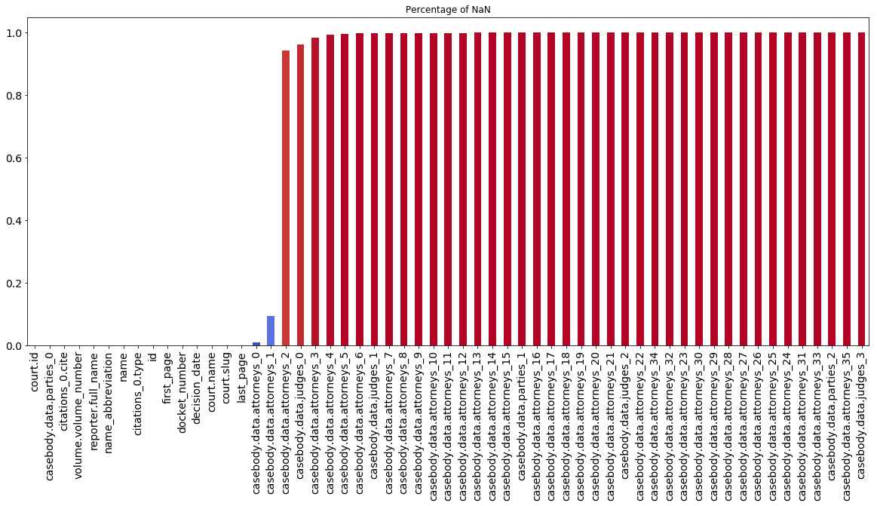

Figure 2 - Diagram of distribution for Not Assigned Values

1. **Data Exploration and Understanding:**

***Handling Unassigned Values:***

* The presence of unassigned values (NaN) in the dataset is visualized to assess its impact on data quality.
* A bar plot showing the percentage of NaN values in different columns is generated for visualization.

***Interpreting the Outputs:***

* Visualizing NaN values allows for the identification of columns with missing data and assessment of their significance.
* Understanding the extent of missing data helps in devising strategies for data imputation or handling missing values during analysis.

1. **Merge All Attorney Columns:**
   * Attorney-related columns are identified using a list comprehension technique, selecting columns containing the term 'attorneys'.
   * A new column named 'all_attorneys' is created by combining non-null values from multiple attorney columns for each row.
   * The original attorney columns are then dropped from the dataset to reduce redundancy.

***Interpreting the Outputs:***

* Merging attorney columns into a single column improves data organization and readability.
* Consolidating attorney information simplifies subsequent analysis tasks and enhances dataset clarity.

Figure 3 - Distribution of Not assigned values for parties.

1. **Merge All Judge Columns:**
   * Similar to the attorney columns, judge-related columns are identified using a list comprehension approach.
   * A new column named 'all_judges' is generated by aggregating non-null values from multiple judge columns for each record.
   * The original judge columns are removed from the dataset to streamline the data structure.

***Interpreting the Outputs:***

* Merging judge columns into a single column facilitates data handling and interpretation.
* Combining judge information into a unified column enhances dataset coherence and prepares it for further analysis.

1. **Handling Missing Values in Parties Columns:**
   * The presence of missing values in the parties’ columns is investigated to assess its impact on data completeness.
   * A subset of the dataset containing only rows with assigned parties’ columns is examined to understand the nature of missing data.

***Interpreting the Outputs:***

* Identifying entries with assigned parties’ columns provides insights into the distribution and significance of missing data.
* Understanding the extent of missing values in parties’ columns informs decision-making regarding data imputation or exclusion during analysis.

1. **Visualization of NaN Values:**
   * A visualization showing the distribution of NaN values in the dataset is generated to visualize the prevalence of missing data across different columns.

***Interpreting the Outputs:***

* Visualizing NaN values aids in identifying columns with high levels of missing data and prioritizing them for further investigation or handling.
* Assessing the distribution of NaN values enables data quality assessment and informs strategies for data preprocessing and analysis.

# **VII. ETL (EXTRACT, TRANSFORM, LOAD)**

## Overview of ETL Process in BetterCallSaul

The ETL (Extract, Transform, Load) process in BetterCallSaul serves as the backbone of our legal analytics platform, facilitating the acquisition, transformation, and loading of legal case data from primary sources into our analytical framework. This comprehensive process involves several intricate steps to ensure the accuracy, completeness, and integrity of the data, ultimately enabling users to derive actionable insights and make informed decisions in various legal domains.

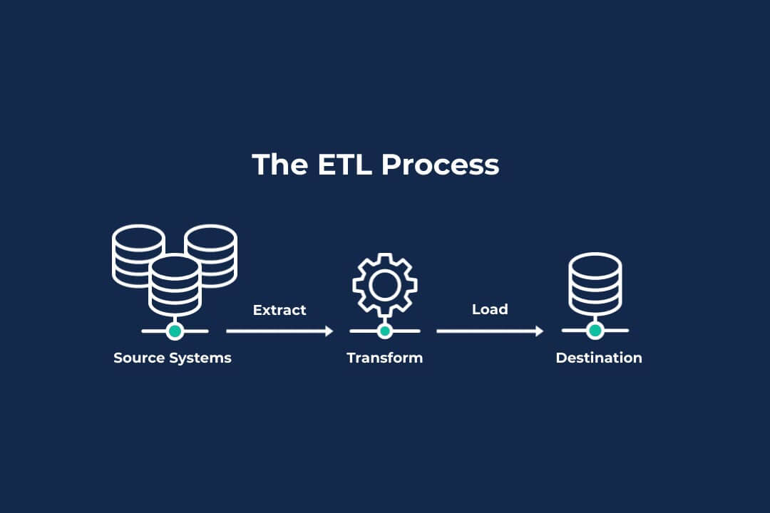

## A. Techniques Used for Extracting Legal Case Data

In BetterCallSaul, the extraction phase involves identifying and selecting JSON files containing relevant legal case data from the Caselaw Access Project dataset. We employ Python-based techniques to read and parse these JSON files, extracting essential attributes such as case ID, case name, decision date, and textual content for each legal case.

1. **Identification of JSON Files**: We meticulously scan and identify JSON files within the Caselaw Access Project dataset that contain the pertinent legal case data relevant to our analysis. This process involves careful consideration of file names, metadata, and content to ensure the selection of the appropriate files.
2. **Parsing with Python**: Once the relevant JSON files are identified, we utilize the versatile capabilities of the Python programming language to read and parse these files efficiently. Python's rich ecosystem of libraries, such as **json** and **pandas**, enables seamless extraction of data from JSON-formatted files, ensuring that no information is overlooked or misrepresented during the parsing process.
3. **Extraction of Attributes**: With the JSON files parsed, we proceed to extract the necessary attributes for each legal case, including but not limited to case ID, case name, decision date, and textual content. Leveraging Python's powerful data manipulation tools, we extract these attributes with precision and accuracy, preparing the data for subsequent processing in the ETL pipeline.

## B. Transformation and Loading Processes

Following the extraction phase, the transformation and loading processes are essential for cleansing, preprocessing, and loading the extracted data into a Neo4j graph database. These processes involve a series of meticulous steps to ensure the integrity and reliability of the data, as well as the accurate representation of relationships within the legal domain.

1. **Data Cleaning and Preprocessing**: In this critical phase, we focus on cleaning and preprocessing the extracted data to remove noise, handle missing values, and standardize formats as needed. Python's extensive libraries, such as **pandas** and **numpy**, provide robust tools for data cleaning and preprocessing, enabling us to identify and address inconsistencies and anomalies effectively.
2. **Schema Definition for Neo4j**: With the cleaned and preprocessed data in hand, we proceed to define the schema for the Neo4j graph database, specifying node labels and relationship types based on the nature of the legal case data. This schema definition serves as a blueprint for organizing and structuring the data within the graph database, ensuring coherence and consistency in data representation.
3. **Mapping to Graph Schema**: Once the schema is defined, we map the extracted data to the graph schema, converting entities such as legal cases, parties, and citations into nodes and relationships within the Neo4j graph database. This mapping process involves careful consideration of entity attributes and relationships, ensuring that the graph structure accurately reflects the complex interconnections within the legal domain.

## C. Loading Data into Neo4j Graph Database

The final phase of the ETL process entails loading the transformed data into the Neo4j graph database, where it can be queried, analyzed, and visualized to derive actionable insights and make informed decisions. This loading process involves establishing a connection to the Neo4j database, executing Cypher queries to create nodes and relationships based on the transformed data, and ensuring that the graph structure accurately represents the relationships between entities in the legal domain.

1. **Neo4j Python Driver**: Using the Neo4j Python driver, we establish a connection to the Neo4j database from the Python environment, enabling seamless interaction and data exchange between the two systems. The Python driver provides a user-friendly interface for executing Cypher queries and managing transactions within the Neo4j database, ensuring efficient data loading and manipulation.
2. **Cypher Query Execution**: With the connection established, we execute Cypher queries to create nodes and relationships in the Neo4j database based on the transformed data. Cypher is a powerful query language specifically designed for graph databases like Neo4j, allowing us to express complex graph patterns and operations with ease and efficiency.
3. **Data Loading**: Finally, we load the transformed data into the Neo4j graph database, ensuring that the graph structure accurately reflects the relationships between entities in the legal domain. This loading process is conducted systematically, with careful validation and verification to ensure the integrity and reliability of the data at every step.

By meticulously executing each phase of the ETL process, BetterCallSaul ensures the integrity, reliability, and accessibility of legal case data within the Neo4j graph database, empowering users to derive actionable insights and make informed decisions in various legal domains.

# **VIII. ARCHITECTURE**

## A. Design and Architecture of BetterCallSaul

The design and architecture of BetterCallSaul are meticulously crafted to ensure efficient processing of legal documents and seamless interaction with users. At its core, BetterCallSaul employs a sophisticated architecture that encompasses various components and modules working in tandem to deliver accurate and timely legal counsel.

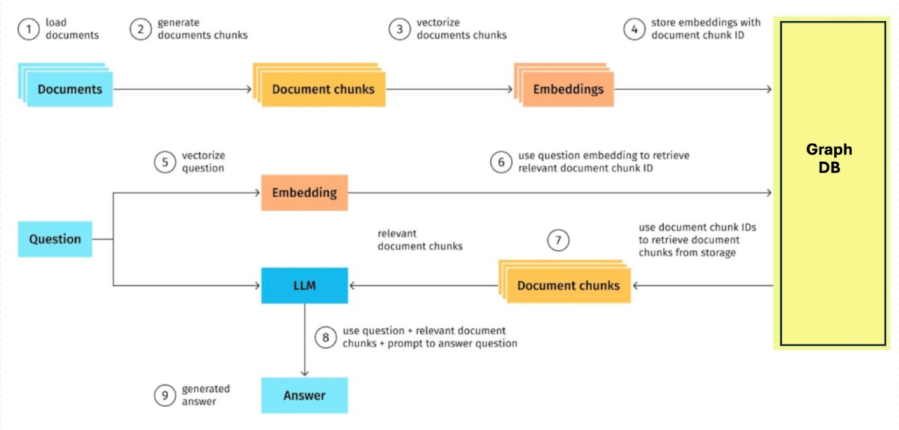

Figure 4 - Architecture of BetterCallSaul

## B. Components and Modules of the Chatbot System

BetterCallSaul comprises several key components and modules that enable its functionality and performance:

1. **Document Loading**: Legal documents are loaded into the system, where they undergo preprocessing and indexing for efficient retrieval.
2. **Document Chunk Generation**: The loaded documents are segmented into smaller chunks of text to facilitate targeted analysis and retrieval.
3. **Vectorization**: Both the documents and document chunks undergo a vectorization process, converting them into numerical representations. This enables efficient comparison and retrieval of relevant information during query processing.
4. **Storage and Embedding**: The vector representations, known as embeddings, are stored along with unique identifiers for each document chunk. This ensures quick and accurate retrieval of relevant information during query processing.
5. **Question Processing**: When a legal question is posed to BetterCallSaul, it undergoes a similar vectorization process to convert it into a numerical representation.
6. **Relevant Document Retrieval**: The vector representation of the question is used to retrieve IDs of relevant document chunks from storage.
7. **Answer Generation**: The retrieved document chunks serve as prompts for the Language Model-based Legal (LLM) system, which generates the final answer to the legal question.

## C. Scalability and Performance Considerations

Scalability and performance are paramount considerations in the design of BetterCallSaul:

1. **Scalability**: BetterCallSaul is designed to scale horizontally to accommodate increasing volumes of legal documents and user queries. This is achieved through distributed computing and storage architectures that can seamlessly scale up or down based on demand.
2. **Performance**: Performance optimization is a continuous focus in BetterCallSaul, with emphasis on reducing latency and improving response times for user queries. This involves optimizing algorithms, leveraging parallel processing techniques, and employing caching mechanisms to enhance system throughput and efficiency.
3. **Resource Management**: Efficient resource allocation and management are critical for maintaining optimal performance in BetterCallSaul. This includes provisioning adequate computing resources, optimizing data storage and retrieval mechanisms, and implementing load balancing strategies to evenly distribute workload across servers.

By prioritizing scalability and performance considerations in its design and architecture, BetterCallSaul ensures robustness, reliability, and responsiveness in providing legal counsel to users. The system architecture is engineered to handle large volumes of legal documents and user queries efficiently, while maintaining high levels of accuracy and usability.

## D. Code Summary

**1. Data Processing:**

The initial stage involves the extraction, transformation, and loading (ETL) of legal case data from a JSONL file. A RecursiveCharacterTextSplitter object named text_splitter is employed to split the text into smaller, manageable chunks. These chunks, along with relevant metadata, are then transformed into a structured format and stored in a new JSON file.

**2. Chunk Node Creation:**

The process of chunk node creation involves merging a new node representing each text chunk into the Neo4j graph database. A Cypher query is executed to merge the node while ensuring its uniqueness based on the provided chunk ID. Properties such as case ID, chunk ID, case name, decision date, source, court, and text content are assigned to each node.

**3. Vectorization and Embedding:**

Following chunk creation, a vector index named case_chunks is established within the Neo4j database for efficient retrieval. Each node's text content is encoded into a vector representation using OpenAI's encoding service, with the resulting vector assigned to the textEmbedding property. This vectorization process facilitates similarity analysis and information retrieval during subsequent queries.

**4. Vector-based Search Function:**

The vector-based search function utilizes the vector index to perform similarity searches in the Neo4j graph database. Question encoding, using OpenAI's encoding service, enables the retrieval of top-k similar nodes along with their scores and relevant properties. This function optimizes the search process by leveraging pre-calculated similarities stored within the vector index.

**5. Integration with Chatbot Chain:**

Integration with the chatbot chain involves creating a retriever from the vector store and instantiating a question-answering chain using OpenAI's Chat model. This chain leverages the retrieved information from the Neo4j graph database to generate relevant responses to user queries. Additionally, a windowed retrieval mechanism is implemented to consider contextual information, enhancing the comprehensiveness of responses.

**6. Pretty Chain Response:**

The pretty chain response function formats and prints the response generated by the chatbot chain for a given question. It extracts the answer from the returned output, ensuring clarity and readability for the end-user.

**7. Windowed Retrieval Configuration:**

A new Neo4jVector instance, vector_store_window, is created to facilitate windowed retrieval in query processing. The retrieval query, retrieval_query_window, is configured to include nodes within a context window based on their relationships and adjacency. This windowed retrieval mechanism provides additional context and relevant information to enhance the accuracy of responses.

# **IX. STORAGE (Neo4J)**

## A. Storage Requirements for Legal Case Data

The storage of legal case data in BetterCallSaul is governed by several key requirements aimed at ensuring scalability, reliability, and security:

1. **Robust Storage Solution**: BetterCallSaul utilizes Neo4j, a graph database, for the robust storage of caselaw data and metadata. Neo4j's graph-based architecture is well-suited for representing complex relationships between legal entities and facilitating efficient querying and analysis.
2. **Scalable Storage Capacity**: As the volume of legal case data continues to grow, it is essential to ensure that the storage solution can scale seamlessly to accommodate this growth. Neo4j's scalability features, such as sharding and clustering, enable the platform to handle increasing data volumes and user interactions without compromising performance.
3. **Redundancy and Backups**: To safeguard against data loss and ensure data integrity, BetterCallSaul implements redundancy and backup mechanisms. Neo4j's replication and failover capabilities enable data redundancy across multiple nodes, while regular backups are performed to mitigate the risk of data loss in the event of hardware failures or disasters.
4. **Cloud Storage Integration**: In addition to Neo4j, BetterCallSaul leverages cloud storage solutions for storing unstructured text data associated with legal documents.

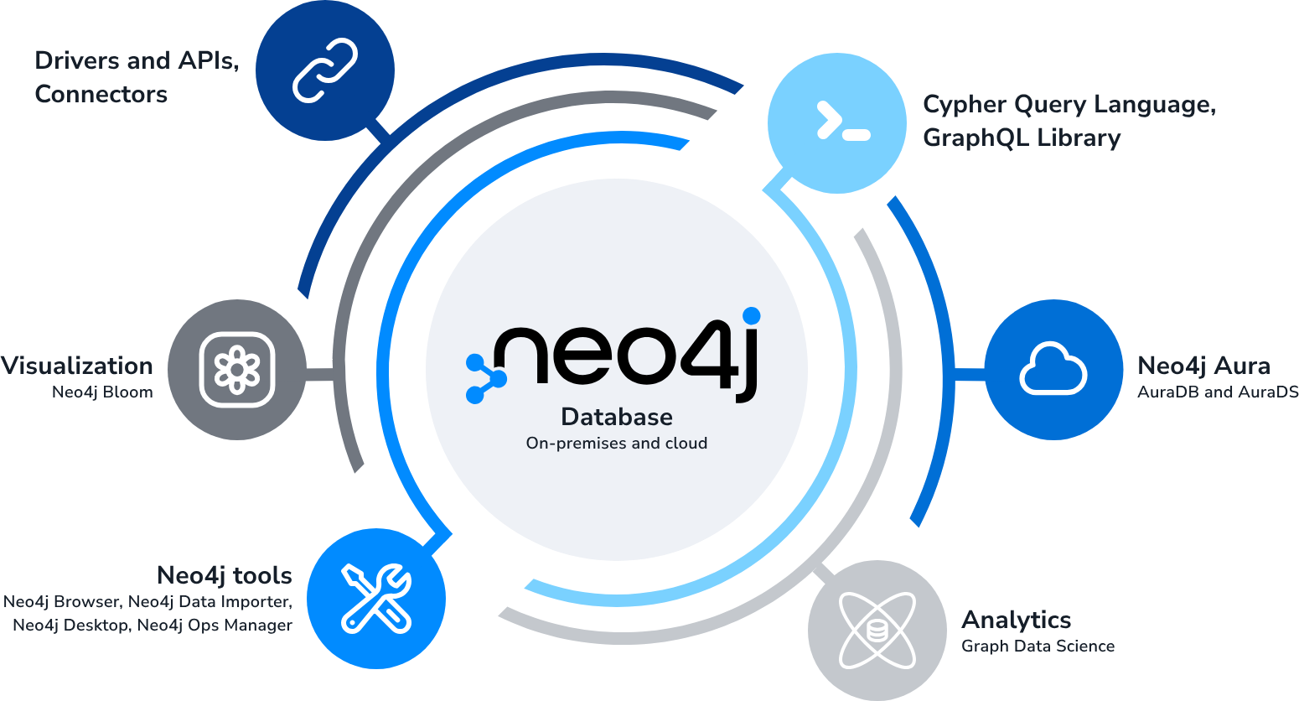

Figure 5- Neo4J integration with different services.

## B. Data Storage Solutions Employed in BetterCallSaul

BetterCallSaul employs a combination of storage solutions to meet the diverse requirements of storing legal case data and text embeddings:

**Neo4j Graph Database**: Neo4j serves as the primary storage solution for legal case data and metadata in BetterCallSaul. Its graph-based data model enables efficient representation of relationships between legal entities, facilitating complex queries and analysis.

Neo4j is a highly scalable, native graph database that stores and queries data as a graph. It represents data as nodes and relationships, making it ideal for handling complex, connected data such as social networks, fraud detection systems, and recommendation engines. The core language for querying Neo4j is Cypher, which is intuitive and efficient. Neo4j is high-performance, scalable, and open source, making it a versatile database used by organizations such as Goldman Sachs, eBay, and Cisco. It can easily handle millions of nodes and relation

**1. Graph Database Model:**

* Neo4j is a native graph database, which means it fully embraces the graph model from storage to query execution.
* In a graph, data is represented as nodes (entities) connected by relationships (edges). This structure allows for rich and expressive data modeling.
* Unlike relational databases, where data is stored in tables with fixed schemas, Neo4j’s schema-less nature allows you to evolve your data model dynamically.

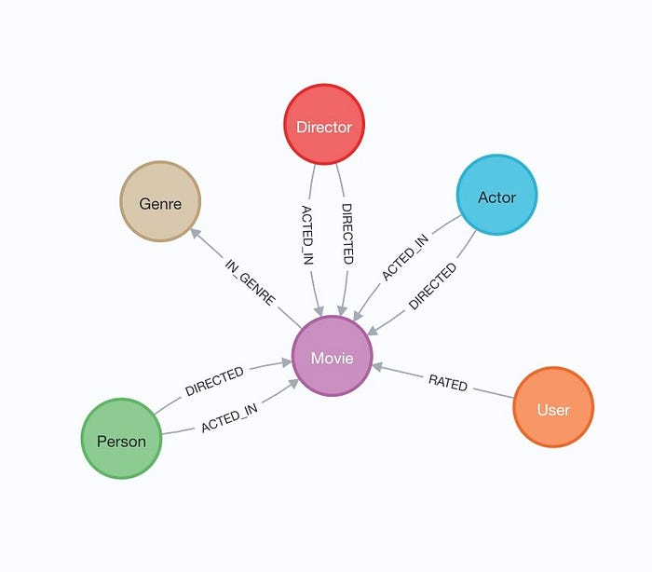

Figure 6 - An example of how a graph database looks like

1. **Storage and Durability:**

* Neo4j’s data is persisted to storage for long-term durability.
* The database files are typically located in the data/databases/graph.db directory within the Neo4j data directory.
* Key files include:
  + neostore.nodestore.db: Stores node-related data.
  + neostore.relationshipstore.db: Stores relationship data.
  + neostore.propertystore.db: Holds properties for nodes and relationships.
  + neostore.propertystore.db.strings: Stores string property values.
  + neostore.propertystore.db.arrays: Stores array property values.
  + Indexed properties have their own storage size based on average property value size.
* Neo4j uses fixed record lengths to persist data, and offsets in these files determine how to fetch data for queries.

1. **Property Storage:**

* Properties (key-value pairs) play a crucial role in Neo4j.
* Each property record has a payload of 32 bytes, divided into four 8-byte blocks.
* Fields within a property record:
* Key and type (occupying 3.5 bytes).
* Values (boolean, byte, short, int, char, float) fit in the remaining bytes.
* Long values or doubles are stored in separate blocks.
* References to string or array stores are also included.
* Properties are stored as linked lists of fixed-size records, pointing to the next property.

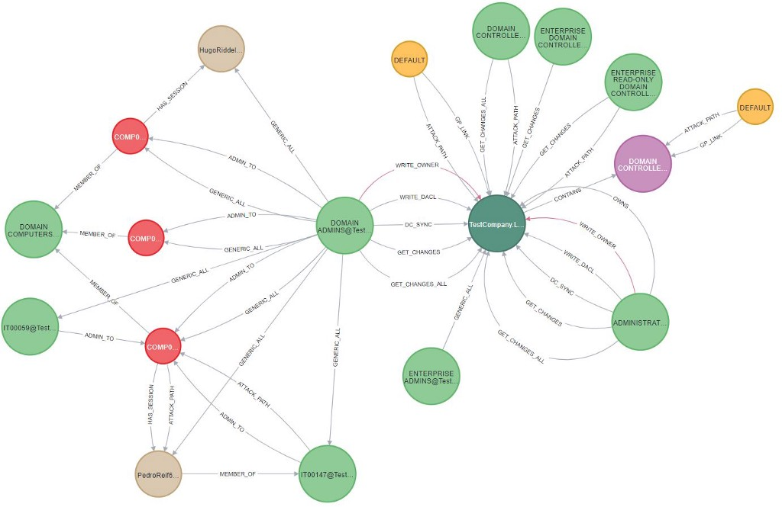

Figure 7 - An example of Neo4J node structure and relationship.

## C. Ensuring Data Security and Compliance

Data security and compliance are paramount considerations in the storage of legal case data in BetterCallSaul:

1. **Encryption and Access Controls**: To protect sensitive data from unauthorized access, BetterCallSaul implements encryption and access controls at multiple layers of the storage infrastructure. Encryption mechanisms such as SSL/TLS are employed to secure data in transit, while access controls are enforced at the database and application levels to restrict access to authorized users.
2. **Regulatory Compliance**: BetterCallSaul adheres to regulatory requirements such as GDPR (General Data Protection Regulation) and HIPAA (Health Insurance Portability and Accountability Act) for handling legal data. This includes implementing measures to ensure data privacy, confidentiality, and integrity in accordance with regulatory guidelines.
3. **Best Practices**: In addition to regulatory compliance, BetterCallSaul follows industry best practices for data privacy and security. This includes regular security audits, vulnerability assessments, and adherence to security standards such as ISO 27001 to maintain the integrity and confidentiality of legal case data.

By implementing robust storage solutions, ensuring data security and compliance, and leveraging cloud storage features for enhanced management and security, BetterCallSaul provides a secure and reliable platform for storing and accessing legal case data, enabling users to derive actionable insights and make informed decisions with confidence.

## Popular Use Cases for Neo4j

Neo4j is a graph database that can be used for a wide variety of applications. Here are some of the most popular use cases:

* **Social networks**: Neo4j can be used to store and query social network data. This could include data such as friendships, likes, and comments. For example, Neo4j could be used to track the relationships between people on Facebook or to analyze the popularity of different hashtags on Twitter.

Figure 8- Neo4j use cases.

* **Fraud detection**: Neo4j can be used to detect fraud. This could be done by analyzing patterns of transactions or by tracking the relationships between people and organizations. For example, Neo4j could be used to identify suspicious credit card transactions or to track the movements of money through a network of shell companies.
* **Recommendation engines**: Neo4j can be used to build recommendation engines. This could be done by analyzing the relationships between users and products or by tracking the browsing history of users. For example, Neo4j could be used to recommend products to customers on Amazon or to suggest movies to users on Netflix.
* **Log analysis**: Neo4j can be used to analyze logs. This could be done by tracking the relationships between events or by analyzing the patterns of events. For example, Neo4j could be used to troubleshoot network problems or to investigate security breaches.

# **X. ANSWER RETRIEVAL**

In the pursuit of delivering accurate and relevant responses to user queries, BetterCallSaul employs a sophisticated answer retrieval mechanism. This chapter delves into the intricate process of answer retrieval, outlining the steps involved and the underlying technologies utilized to ensure the precision and efficacy of the responses provided.

## A. Vectorize the Question

The journey of answer retrieval begins with the vectorization of the user's question. Utilizing advanced NLP techniques, BetterCallSaul transforms the textual query into a numerical representation known as a vector. This vector encapsulates the semantic meaning and context of the question, enabling the system to compare it with the vectors representing the legal documents stored in its database.

## B. Retrieve Closest Chunk Based on Vector Similarity

With the question vectorized, BetterCallSaul proceeds to search for the closest matching document chunk in its database. Leveraging vector similarity metrics such as cosine similarity, the system compares the vectorized question with the vectors representing each document chunk. The document chunk exhibiting the highest similarity score with the question vector is identified as the most relevant candidate for answer retrieval.

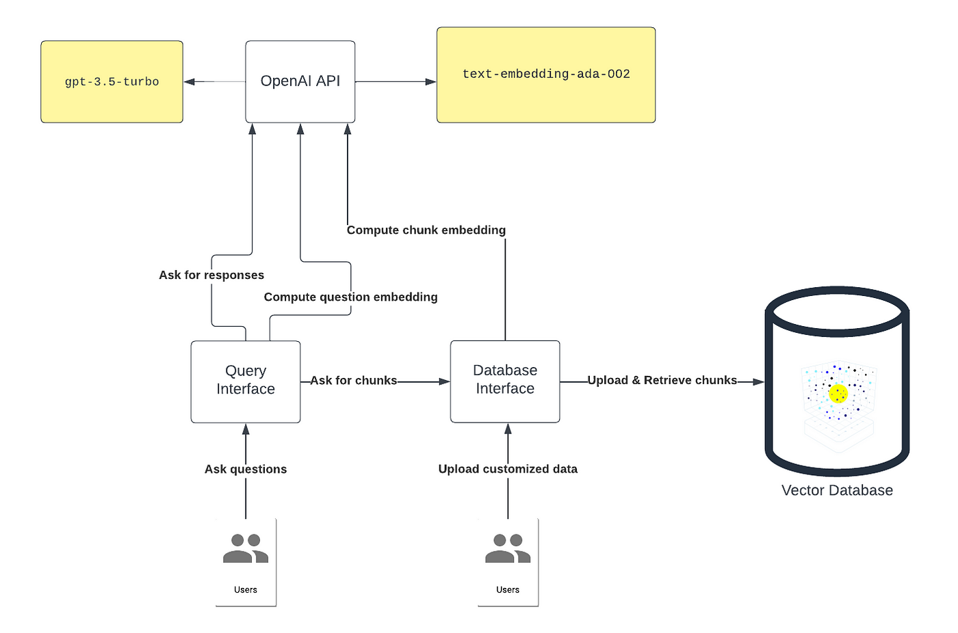

## C. Question + Docs (Relevancy)

To further enhance the relevancy and accuracy of the retrieved answer, BetterCallSaul considers not only the user's question but also the surrounding legal context provided by the relevant document chunk. By analyzing the textual content of both the question and the selected document chunk, the system ensures that the response generated is contextually appropriate and aligned with the user's query.

## D. Answer the Question

BetterCallSaul proceeds to generate the final answer. Leveraging its advanced NLP capabilities and access to comprehensive legal knowledge, the system formulates a concise and informative response tailored to address the user's specific legal inquiry. Whether elucidating legal principles, citing relevant case law, or providing practical guidance, BetterCallSaul endeavors to deliver responses that are accurate, insightful, and actionable.

BetterCallSaul ensures that users receive timely, relevant, and reliable responses to their legal queries. Through the seamless integration of NLP techniques, vector similarity calculations, and contextual analysis, the system navigates the complexities of legal language and content to empower users with the knowledge and insights they need to make informed decisions and navigate the legal landscape with confidence.

As the legal landscape continues to evolve, the integration of chatbot technology has emerged as a transformative force in democratizing access to legal information. Central to the development of a robust legal chatbot is its underlying architecture, which encompasses a series of interconnected modules and processes. In this article, we delve into the code snippets provided in seven steps, unraveling the architecture of a legal chatbot piece by piece. Through this exploration, we aim to demystify architecture and provide readers with a comprehensive understanding of its inner workings.

**1. Retrieval Query Window:** The first step in the code focuses on defining a retrieval query window, which retrieves legal text data from a database based on specific criteria. This retrieval query window serves as the initial point of interaction between the chatbot and the legal data repository, laying the foundation for subsequent processing steps.

**2. Vector Store Window:** Following the retrieval of legal text data, the next step involves creating a vector store window. This vector store utilizes machine learning techniques to transform textual information into high-dimensional vectors, enabling efficient similarity analysis and information retrieval. By leveraging embeddings and indices, the vector store enhances the chatbot's ability to retrieve relevant legal information.

**3. Creating a Retriever:** With the vector store in place, the next step entails creating a retriever from the vector store. This retriever acts as a bridge between the vectorized legal text data and the chatbot's question and answer chain, facilitating seamless information retrieval and response generation.

**4. Creating a Chatbot Question & Answer Chain:** Once the retriever is established, the next step involves creating a chatbot question and answer chain. This chain integrates natural language processing techniques and machine learning algorithms to interpret user queries, retrieve relevant legal information, and generate contextually appropriate responses. By combining retrieval-based and generative approaches, the chatbot can effectively address a wide range of legal queries.

**5. Defining User Queries:** In this step, user queries are defined, serving as the input to the chatbot question and answer chain. These queries represent the inquiries posed by users seeking legal information, ranging from case summaries to specific legal rulings.

**6. Answering User Queries:** Once the user queries are defined, the chatbot question and answer chain springs into action, processing the queries and generating responses. Leveraging the retrieved legal text data and machine learning algorithms, the chatbot formulates coherent and contextually relevant answers to user queries, empowering users with accurate legal insights.

**7. Iterative Optimization:** The final step in the code snippet pertains to iterative optimization, wherein machine learning algorithms drive the optimization process based on analytics insights and user feedback. This iterative approach enables the chatbot to continuously refine its performance and functionality, enhancing user satisfaction and overall effectiveness over time.

# **XI. CYPHER AND RAG INTEGRATION: ENHANCING ANSWER RETRIEVAL**

Cypher, a powerful query language designed specifically for graph databases, and RAG (Retriever-Aggregator-Generator), a sophisticated model combining retrieval and generation techniques, form the backbone of BetterCallSaul's answer retrieval mechanism. This chapter delves into the integration of Cypher and RAG, elucidating how these complementary components collaborate to deliver accurate and contextually relevant responses to user queries.

## A. Cypher: The Query Language for Graph Databases

Cypher serves as the interface between BetterCallSaul and its underlying graph database, facilitating the retrieval of relevant legal information stored in a graph format. Tailored for graph-based data structures, Cypher enables users to express complex queries using a concise and intuitive syntax. By specifying patterns of nodes and relationships within the graph, users can effectively traverse the graph and extract the information they need.

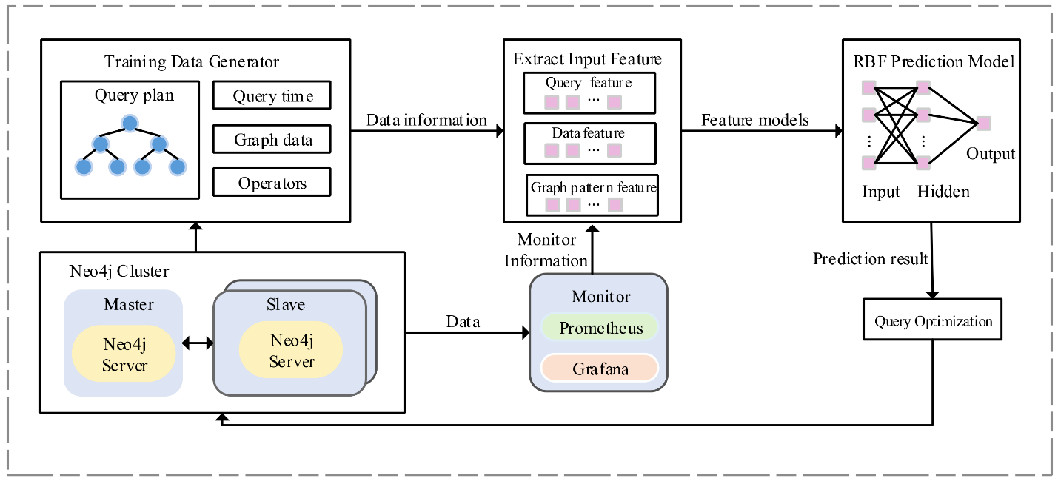

Figure 9 - Using cypher queries with Neo4j Database for prediction

When a Cypher query is executed against the graph database, the database engine traverses the graph, identifying nodes and relationships that match the query criteria. This traversal process allows BetterCallSaul to retrieve relevant legal documents, passages of text, or other pertinent information from the graph, laying the groundwork for subsequent processing and response generation.

## B. RAG: The Retrieval-Aggregation-Generation Model

RAG represents a paradigm shift in natural language understanding and response generation, leveraging a multi-stage approach to produce accurate and contextually relevant responses to user queries. Comprising three key components - Retriever, Aggregator, and Generator - RAG seamlessly integrates retrieval and generation techniques to bridge the gap between user queries and informative responses.

1. **Retriever**: The retrieval component of RAG is responsible for identifying and extracting relevant passages of text or documents from the available data sources. In the context of BetterCallSaul, Cypher plays a pivotal role in the retrieval process, enabling the system to retrieve nodes and relationships from the graph database that match the query criteria specified by the user.
2. **Aggregator**: Once the relevant nodes and relationships have been retrieved, the aggregation component of RAG, utilizing Cypher queries, consolidates this information into a coherent representation. By aggregating and summarizing the retrieved data, the aggregator prepares the groundwork for the subsequent generation of a response.

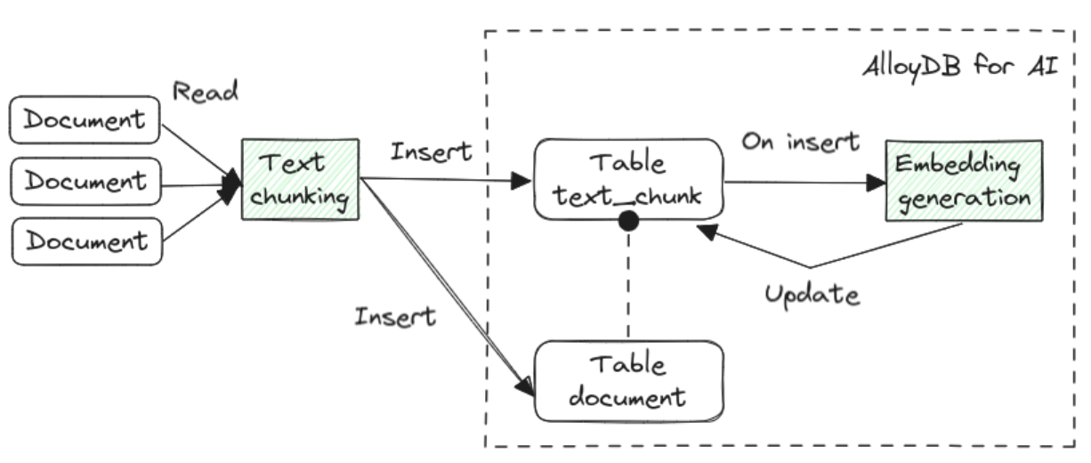

Figure 10 - RAG Architecture for answering queries

1. **Generator**: The generation component of RAG utilizes the aggregated information, along with additional context and knowledge, to generate a natural language response to the user query. Drawing upon advanced natural language processing techniques and machine learning algorithms, the generator crafts a response that is informative, coherent, and contextually relevant.

## C. Integration of Cypher and RAG: Synergy for Accurate Response Generation

The coordination between Cypher and RAG within the BetterCallSaul ecosystem is pivotal in ensuring the accuracy and relevance of the responses provided to users. By leveraging Cypher queries to retrieve relevant nodes and relationships from the graph database, BetterCallSaul lays the foundation for the subsequent processing and response generation performed by RAG.

The retrieved nodes and relationships serve as input to the aggregation and generation components of RAG, enabling the system to construct a coherent narrative and generate a natural language response that addresses the user's query effectively. Through this seamless integration, BetterCallSaul delivers responses that are not only accurate and informative but also tailored to the specific legal context and user requirements.

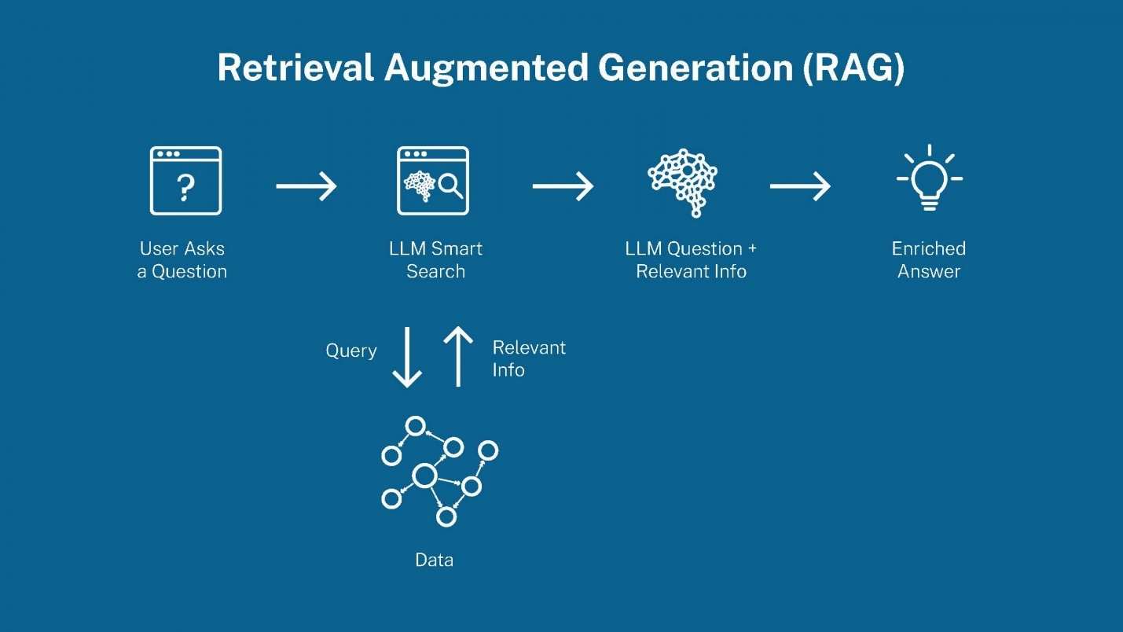

Figure 11 - Visualizing Steps in RAG

In summary, the integration of Cypher and RAG represents a symbiotic relationship that underpins the answer retrieval process in BetterCallSaul. By harnessing the capabilities of Cypher for graph-based query execution and leveraging the multi-stage approach of RAG for response generation, BetterCallSaul empowers users with accurate, contextually relevant, and actionable legal insights.

# **XII. ANALYTICS**

## A. Natural Language Processing Techniques Used

BetterCallSaul leverages advanced Natural Language Processing (NLP) techniques to extract insights and generate responses from legal case data:

1. **Data Retrieval:**
   * The data retrieval process involves querying the Neo4j graph database using Cypher queries to extract relevant legal information based on user inquiries.
   * Techniques such as graph traversal and pattern matching are employed to identify chunks of text associated with the longest windows of legal discourse.
2. **Text Preprocessing:**
   * Before analysis, text data undergoes preprocessing steps such as tokenization, stop word removal, and stemming to enhance the quality of analysis by reducing noise and improving the relevance of extracted information.
3. **Named Entity Recognition (NER):**
   * NER techniques are employed to identify and classify entities such as names of parties, court jurisdictions, and legal citations within legal documents. This enables BetterCallSaul to extract relevant information and understand the context of legal cases more effectively.
4. **Sentiment Analysis:**
   * BetterCallSaul utilizes sentiment analysis to assess the sentiment expressed within legal documents, helping users gauge the tone and implications of court decisions or legal arguments.
5. **Topic Modeling:**
   * Topic modeling techniques such as Latent Dirichlet Allocation (LDA) are applied to identify latent topics and themes within legal documents. This enables BetterCallSaul to categorize and organize legal content, making it easier for users to navigate and explore relevant information.
6. **Chatbot Question & Answer Chain:**
   * Natural Language Processing (NLP) techniques are integrated into the construction of the Question & Answer (QA) chain using the RetrievalQAWithSourcesChain framework.
   * The framework utilizes NLP algorithms to comprehend user queries, retrieve pertinent legal information, and formulate coherent responses.
   * Parameters such as temperature and openai_api_key are fine-tuned to optimize the responsiveness and accuracy of the QA chain.
7. **Response Evaluation:**
   * NLP techniques are employed to evaluate the coherence, relevance, and accuracy of the chatbot's responses.
   * Textual similarity measures may be used to compare the generated responses against ground truth legal knowledge, assessing the chatbot's efficacy in interpreting user queries.
8. **Feedback Integration:**
   * NLP techniques are leveraged to solicit and analyze user feedback, extracting qualitative insights into user experiences and preferences.
   * Sentiment analysis algorithms may be employed to gauge user satisfaction levels and identify areas for improvement in the chatbot's performance and functionality.

## B. Machine Learning Algorithms for Legal Data Analysis

In addition to NLP techniques, BetterCallSaul employs various machine learning algorithms for in-depth analysis of legal data:

1. **Supervised Learning**: Supervised learning algorithms such as Support Vector Machines (SVM) and Random Forest are used for tasks such as legal document classification, case prediction, and legal text summarization.
2. **Unsupervised Learning**: Unsupervised learning algorithms like K-means clustering and Hierarchical Clustering are utilized for grouping similar legal documents based on content similarity, facilitating exploratory analysis and pattern discovery.
3. **Deep Learning**: Deep learning models such as Convolutional Neural Networks (CNNs) and Recurrent Neural Networks (RNNs) are employed for tasks requiring sequence modeling and text generation, such as case summarization and legal question answering.
4. **Vectorization and Embedding:**

* Machine learning algorithms are utilized for vectorization and embedding of legal text data, transforming textual information into high-dimensional representations.
* Techniques such as word embeddings or contextual embeddings may be employed to represent legal documents in a high-dimensional vector space, enabling similarity analysis and information retrieval.

1. **Iterative Optimization:**

* Machine learning algorithms drive the iterative optimization process, fine-tuning the chatbot's performance and functionality based on analytics insights and user feedback.
* Reinforcement learning algorithms may be used to optimize dialogue flows and response generation mechanisms, enhancing the chatbot's responsiveness and user satisfaction over time.

## C. Analytical Capabilities of BetterCallSaul

BetterCallSaul offers a wide range of analytical capabilities to empower users in legal research and decision-making:

1. **Case Similarity Search**: Users can perform similarity searches to find legal cases similar to a given query, enabling them to identify relevant precedents and make informed decisions based on past rulings.
2. **Legal Trend Analysis**: BetterCallSaul enables users to analyze legal trends and patterns over time, identifying emerging issues, evolving jurisprudence, and changing regulatory landscapes.
3. **Legal Document Summarization**: Users can generate concise summaries of legal documents, extracting key insights and arguments to facilitate quick understanding and decision-making.
4. **Predictive Analytics**: BetterCallSaul employs predictive analytics techniques to forecast legal outcomes, assess case probabilities, and provide insights into potential litigation strategies.
5. **Interactive Visualization**: The platform offers interactive visualization tools to present legal data in intuitive and visually appealing formats, enabling users to explore trends, relationships, and patterns within legal content.

By harnessing the power of NLP techniques, machine learning algorithms, and advanced analytical capabilities, BetterCallSaul empowers users to navigate the complexities of legal research, analysis, and decision-making with confidence and efficiency.

# **XIII. DEMO**

**Prompt 1:**

Output: A response box shows the chatbot’s answer to the sample question. The answer details the case of People v. Everette, which involved a murder conviction that was appealed successfully based on self-defense and voluntary manslaughter claims.

**Prompt 2:**

**Output:** A response box shows the chatbot’s answer to the sample question. The answer details the case of Joseph A. Couri vs. Anthony J. Couri, which involved a real estate dispute. The verdict was in favor of the plaintiff for $122,690 and costs, with an additional $32,500 and costs. The court found that the deed conditions and the right to repurchase were not unreasonable restraints on alienation.

**Prompt 3:**

**Output:** A response box shows the chatbot’s answer to the sample question. The answer details the case of CHARLENE HELTON DRAYSON v. GEORGE W. WOLFF which involved a dispute over deed provisions and a right to repurchase. The court determined that the conditions in the deed were valid and not unreasonable restraints on alienation.

**Prompt 4:**

**Output:** A response box shows the chatbot’s answer to the sample question. The answer mentioned a case that involves murder, where the plaintiff was THE PEOPLE OF THE STATE OF ILLINOIS and the defendant was DONALD EVERETTE.

# **XIV. SOLUTION OVERVIEW**

Our chatbot solution, BetterCallSaul, represents a groundbreaking advancement in the realm of legal assistance, harnessing cutting-edge technology to provide users with intuitive access to legal information and guidance. This chapter provides a detailed overview of the key components and functionalities of BetterCallSaul, highlighting its role in democratizing access to legal knowledge and empowering users with the tools they need to navigate the complexities of the legal landscape.

## A. Chatbot Interface

At the heart of BetterCallSaul lies its user-friendly chatbot interface, which serves as the primary interaction point for users seeking legal assistance. The chatbot interface is designed to enable users to pose legal queries in natural language and receive accurate and relevant responses in real-time. By leveraging advanced natural language processing (NLP) techniques, the chatbot interface ensures seamless communication between users and the system, enhancing user experience and accessibility.

## B. NLP Engine

BetterCallSaul incorporates an advanced NLP engine that powers its ability to understand user queries, extract key information, and formulate accurate responses based on the context of legal questions. The NLP engine is trained on a vast corpus of legal texts and documents, enabling it to decipher complex legal language and provide nuanced and contextually relevant answers to user queries. Through continuous learning and refinement, the NLP engine ensures the accuracy and effectiveness of the chatbot's responses, enhancing its utility and reliability as a legal assistance tool.

## C. Caselaw Database

Central to the functionality of BetterCallSaul is its robust caselaw database, which stores a comprehensive collection of Illinois caselaw data. The database includes key attributes such as case names, decision dates, court names, and case opinions, structured for efficient retrieval and analysis. By leveraging this vast repository of legal precedents and rulings, BetterCallSaul empowers users to access relevant legal information and insights with ease, facilitating informed decision-making and legal research.

## D. Text Embeddings and Graph Database

To enhance the efficiency and accuracy of legal information retrieval, BetterCallSaul employs text embedding techniques to transform caselaw text data into numerical representations. These text embeddings are stored in a dedicated graph database, enabling fast and scalable similarity search and retrieval of relevant caselaw documents based on user queries. By leveraging the power of text embeddings and graph databases, BetterCallSaul ensures that users can quickly access the most pertinent legal precedents and insights to address their legal queries and concerns.

## E. Cloud Integration

BetterCallSaul seamlessly integrates with cloud storage solutions to store large volumes of caselaw data securely and reliably. By leveraging cloud infrastructure, BetterCallSaul ensures scalability, flexibility, and accessibility, enabling users to access legal information anytime, anywhere. Cloud integration also enhances data security and compliance, ensuring that sensitive caselaw data is protected and that

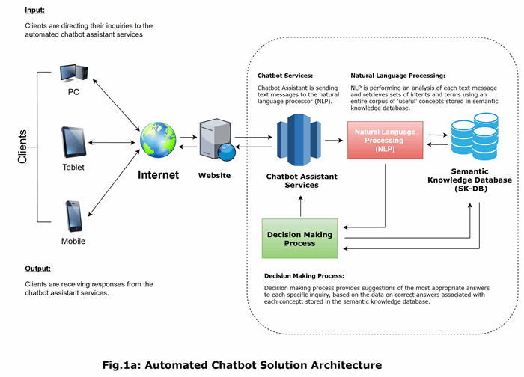

Figure 12 - Augmented Chatbot Solution Architecture

regulatory requirements are met.

## F. Data Privacy and Compliance

In line with legal and regulatory standards, BetterCallSaul prioritizes data privacy and compliance, implementing robust measures to protect sensitive caselaw data and ensure adherence to regulatory requirements. This includes encryption, access controls, and data anonymization techniques to safeguard user privacy and confidentiality. By prioritizing data privacy and compliance, BetterCallSaul instills trust and confidence in its users, ensuring that their legal queries and concerns are handled with the utmost confidentiality and integrity.

Overall, BetterCallSaul represents a transformative solution in the field of legal assistance, leveraging advanced technology and comprehensive caselaw data to democratize access to legal knowledge and empower users with the tools they need to navigate the legal landscape effectively. Through its user-friendly interface, advanced NLP engine, robust caselaw database, and cloud integration capabilities, BetterCallSaul aims to streamline the legal research process, enhance legal literacy, and contribute to a more informed and equitable society.

# **XV. FINANCIAL IMPACT, POTENTIAL USES, AND FUTURE APPLICATIONS**

BetterCallSaul represents not only a revolutionary advancement in legal assistance but also holds significant potential for driving tangible financial impact, expanding its utility across diverse domains, and shaping the future landscape of AI-powered solutions. This chapter explores the multifaceted dimensions of BetterCallSaul's financial implications, potential use cases, additional features, and its application in other domains with similar solutions, backed by industry statistics, forecasting, and practical insights.

## A. Financial Impact

The adoption of BetterCallSaul promises substantial cost savings and efficiency gains for legal practitioners, organizations, and individuals alike. By automating tedious and time-consuming tasks such as legal research, document analysis, and response generation, BetterCallSaul streamlines workflows, reduces manual labor costs, and enhances productivity. Industry studies indicate that AI-powered legal solutions can yield cost savings ranging from 20% to 40%, with potential annual savings amounting to billions of dollars globally.

Moreover, the scalability and versatility of BetterCallSaul enables it to cater to a wide range of users, from solo practitioners to large law firms and corporate legal departments. This scalability translates into significant cost efficiencies, as the solution can adapt to varying workloads and user requirements without significant overhead costs. By optimizing resource allocation and maximizing operational efficiency, BetterCallSaul delivers measurable financial benefits to its users, positioning itself as a cost-effective solution for legal assistance.

## B. Potential Uses and Additional Features

The potential uses of BetterCallSaul extend far beyond its initial scope, encompassing a myriad of applications and scenarios across different industries and domains. In addition to its core functionalities of legal research, analysis, and response generation, BetterCallSaul can be augmented with additional features to further enhance its utility and value proposition.

1. **Analytics**: BetterCallSaul can serve as a powerful tool for legal analytics, enabling users to extract insights from vast repositories of legal data and identify trends, patterns, and anomalies. By leveraging AI-driven analytics capabilities, BetterCallSaul empowers users to make data-driven decisions, anticipate legal risks, and gain a competitive edge in the legal marketplace.
2. **Summary and Report Preparation**: BetterCallSaul can automate the process of summarizing legal documents, preparing reports, and synthesizing complex legal information into concise and actionable insights. This feature streamlines the creation of legal briefs, case summaries, and regulatory compliance reports, saving users time and effort while ensuring accuracy and consistency in documentation.
3. **Other Documents Preparation**: Beyond legal documents, BetterCallSaul can be adapted to prepare a wide range of other documents, including contracts, agreements, and correspondence. By leveraging natural language generation capabilities, BetterCallSaul generates clear and professional-looking documents tailored to user specifications, reducing the burden of manual document creation and enhancing overall efficiency.

## C. Application in Other Domains

The success of BetterCallSaul in the legal domain paves the way for its application in other industries and domains with similar requirements for AI-powered solutions. Industries such as healthcare, finance, and compliance stand to benefit from the capabilities of BetterCallSaul in data analysis, decision support, and document automation. By leveraging its core technologies and adapting them to specific domain requirements, BetterCallSaul can address a wide range of challenges and opportunities across various sectors.

Industry statistics indicate a growing demand for AI-powered solutions in these domains, with market forecasts projecting significant growth in the adoption of AI-driven technologies in the coming years. BetterCallSaul's proven track record, coupled with its flexibility and scalability, positions it as an asset for organizations seeking to leverage AI for competitive advantage and operational excellence.

In summary, BetterCallSaul's financial impact, potential uses, additional features, and application in other domains underscore its transformative potential and enduring relevance in the evolving landscape of AI-powered solutions. By delivering measurable cost savings, enhancing productivity, and unlocking new opportunities for innovation, BetterCallSaul emerges as a game-changing solution with far-reaching implications for businesses, industries, and society.

# **XVI. CONCLUSION**

Our journey through building and understanding this chatbot has shown great promise in making legal assistance more accessible. By leveraging advanced technologies like natural language processing and machine learning, we've created a tool that can decipher legal jargon and provide meaningful insights from vast amounts of legal data.

Through the meticulous processing of legal documents and the implementation of intelligent search mechanisms, our chatbot can efficiently retrieve relevant information and present it in a digestible format. This capability empowers users to make informed decisions, conduct legal research more effectively, and navigate complex legal landscapes with confidence.

Moving forward, continued refinement and enhancement of the chatbot's capabilities will be essential. By fine-tuning algorithms, expanding the scope of legal data sources, and incorporating user feedback, we can further optimize the chatbot's performance and ensure its relevance and utility in real-world scenarios.

In conclusion, our chatbot represents a significant step toward democratizing access to legal information. By harnessing the power of technology, we're bridging the gap between complex legal concepts and everyday individuals, empowering them to engage with the law more confidently and effectively. As we continue to innovate and evolve, the potential impact of this chatbot on legal accessibility and empowerment is truly promising.

# **XVII. PERSONAL CONCLUSION – MANOJ**

# **A. Introduction**

Reflecting on our journey through the development of "BetterCallSaul," a legal chatbot designed to democratize access to legal information, I am reminded of the profound learning and growth opportunities this project presented. Rooted in a passion for generative AI technologies, and driven by a deep desire to make a significant social impact, this project has been both a professional and a personal milestone.

# **B. Personal Motivation and Interest**

The inception of this project was significantly influenced by my fascination with the cutting-edge advancements in generative AI, particularly the innovative applications of Retrieval-Augmented Generation (RAG) models. This interest was further catalyzed by a distressing incident in my community—an unfortunate event where two close friends were brutally attacked by a dog. This incident not only highlighted the urgent need for readily accessible legal advice but also the general public’s lack of awareness about their legal rights and the actions they could legally take.

Witnessing the confusion and helplessness of my friends post-incident, I was compelled to think about how many others might be in similar situations, unaware of their legal rights, and without access to costly legal advice. This realization solidified my resolve to apply my technical skills to create a solution that could offer free, immediate, and reliable legal guidance to anyone in need.

The dog attack incident was not just a call to action but a window into the broader societal issues surrounding legal accessibility. My friends, like many others, were unaware of the specific statutes that could be invoked for their protection and the legal recourse available to them. Their first instinct was to search online, but the overwhelming and often contradictory information only added to their anxiety and confusion. This incident underscored the necessity for a solution that could simplify legal complexities and provide authoritative and tailored legal advice.

# **C. Data Sourcing Struggles**

The challenges in our project was not just technical but also informational—sourcing reliable and comprehensive legal datasets proved to be one of the most daunting aspects of this project. Our quest for data led us to the Illinois caselaw dataset, which, while extensive, required significant effort to clean and structure. The dataset, comprising over 180,000 caselaws dating from the year 1700 to 2000, was riddled with inconsistencies, legal jargon, and incomplete entries. Rigorous data cleaning, normalization, and preprocessing were necessary to make this data usable for our AI model. This process involved not only technical skills in data manipulation but also a nuanced understanding of legal terminologies and concepts, bridging the gap between law and technology.

# **D. My Technical Learnings**

### **1. Navigating RAG Architecture**

The Retrieval-Augmented Generation (RAG) architecture stands as a cornerstone of our legal chatbot's ability to provide precise legal advice. Delving into RAG was akin to exploring a new language, one where AI speaks with the fluency and precision necessary for the legal domain. I learned that RAG ingeniously combines the retrieval of relevant information with the generation of cohesive responses, leveraging the power of transformer-based models like BERT or GPT to enrich the output with context from vast databases.

### **2. Exploring Graph Databases for Complex Data Relationships**

The legal domain, with its intricate network of statutes, cases, and precedents, called for a database solution beyond traditional tabular formats. Graph databases emerged as the perfect fit, mirroring the complex relationships found in legal texts. I learned to represent legal entities as nodes, their interconnections as relationships, and the power of graph theory in uncovering insights that would remain hidden in traditional databases.

### **3. Cypher Queries**

As nodes and relationships formed the tapestry of our legal database, Cypher became the tool of choice for querying this complex web. I learned the syntax and semantics of Cypher, which allowed me to interrogate the graph database with precision. Crafting queries in Cypher was like learning to sculpt data, extracting precise subgraphs that answered specific legal questions posed to our chatbot.

### **4. Synergy of RAG and Graph Databases**

The fusion of RAG architecture with graph databases represented a paradigm shift in my understanding of AI-driven legal assistance. I learned how to leverage RAG's dynamic retrieval capabilities to pull contextually relevant nodes from the graph database, ensuring that the chatbot's responses were both legally accurate and context-aware. This synergy allowed us to build a chatbot that was not just informative but also insightful, offering users legal advice with an understanding of the rich tapestry of legal relationships.

### **5. Streamlit integration for user-friendly UI**

One of the pivotal aspects of our project was the integration of a user-friendly interface that could make legal advice accessible to anyone with an internet connection. To achieve this, we utilized Streamlit, an open-source app framework, which was instrumental in the rapid development and deployment of our legal chatbot's interface. Streamlit's straightforward syntax and powerful capabilities allowed us to transform our complex scripts into shareable web apps effortlessly. Streamlit excelled in simplifying the development process by allowing us to create a clean, effective, and interactive UI without the need for complex front-end technologies. This experience not only sharpened my technical skills in UI development but also deepened my understanding of the importance of user-centric design in technology. Working with Streamlit also expanded our technical horizons. We learned to leverage its capabilities to integrate sophisticated machine learning models into a web environment directly, thus democratizing the access to complex AI-driven solutions.

### **6. Conclusive Learnings from AI Technologies**

Engaging with RAG and graph databases equipped me with not only a set of technical skills but also a strategic mindset. I learned that the true power of AI lies in its ability to weave together disparate pieces of information into a coherent and meaningful narrative. This project was a testament to the potential of AI in transforming complex legal information into accessible knowledge, bridging the gap between legal experts and those in need of guidance.

# **E. Challenges, Growth, and the Synergy Between AI and Legal Frameworks:**

The process of integrating this cleaned data into a responsive AI system tested our skills and patience. The challenge was to develop a system that was not only technically proficient but also legally accurate and user-friendly—ensuring that the legal advice provided was easy to understand for non-experts. This required us to innovate continuously and adaptively, integrating user feedback into iterative improvements, thus enhancing the chatbot's accuracy and usability.

# **F. Future Scope and Development**

Looking forward, the potential for scaling and enhancing "BetterCallSaul" is vast. Plans are already underway to incorporate multilingual capabilities to extend our reach to non-English speaking users, reflecting our commitment to inclusivity. Further, by integrating advanced NLP techniques like sentiment analysis, we aim to make the chatbot more empathetic and responsive to the emotional states of the users, which is often critical in legal situations.

Additionally, exploring the integration of blockchain technology could enhance the security and privacy of the interactions, ensuring that sensitive legal inquiries are protected. This aligns with the increasing global emphasis on data privacy and security.

# **G. Conclusion**

This project has not just been a technical endeavor but a deeply personal journey that has significantly shaped my perspective on the role of technology in societal advancement. The bridge we are building between technological innovation and accessible legal assistance is just the beginning. As we move forward, the goal is to continue refining our solutions, making them more robust, inclusive, and impactful.

# **XVIII. REFERENCES**

* 1. 1.1Top of Form

1. <https://www.kaggle.com/datasets/harvardlil/caselaw-dataset-illinois>
2. <https://case.law/>
3. Vaswani, A., Shazeer, N., Parmar, N., Uszkoreit, J., Jones, L., Gomez, A. N., ... & Polosukhin, I. (2017). Attention is all you need. Advances in neural information processing systems, 30.
4. Augustin, A., Yi, J., Clausen, T., & Townsley, W. M. (2016). A study of LoRa: Long range & low power networks for the internet of things. Sensors, 16(9), 1466.
5. Ovadia, O., Brief, M., Mishaeli, M., & Elisha, O. (2023). Fine-tuning or retrieval? comparing knowledge injection in llms. arXiv preprint arXiv:2312.05934.
6. <https://medium.com/neo4j/enhancing-the-accuracy-of-rag-applications-with-knowledge-graphs-ad5e2ffab663>
7. <https://towardsdatascience.com/intro-to-neo4j-a-graph-database-19958be6c52f>
8. <https://medium.com/illumination/neo4j-cypher-the-complete-guide-for-beginners-d42e59a945ed>
9. <https://learn.deeplearning.ai/courses/knowledge-graphs-rag>
10. <https://bratanic-tomaz.medium.com/constructing-knowledge-graphs-from-text-using-openai-functions-096a6d010c17>
11. <https://medium.com/neo4j/json-based-agents-with-ollama-langchain-9cf9ab3c84ef>
12. <https://medium.com/neo4j/building-a-graph-llm-powered-rag-application-from-pdf-documents-24225a5baf01>
13. <https://towardsdatascience.com/how-to-convert-any-text-into-a-graph-of-concepts-110844f22a1a>
14. https://generativeai.pub/knowledge-graph-extraction-visualization-with-local-llm-from-unstructured-text-a-history-example-94c63b366fed